Scanbuy Dev Ops Intern Exercise:

1. Docker-ized website :

Website configured on apache2.

I have implemented docker-compose to mount the volume where my web content stored and that should allow to make changes on index.html without exec into web server and can change from local machine, that should make changes on hosted site and while doing all this changed docker keep running in the background.

Git Repo : <https://github.com/codekeyur/DevOps-Exercise>

1. S3 hosted website

Created S3 bucket and host same index.html using Terraform script.

Git Repo: <https://github.com/codekeyur/DevOps-Exercise>

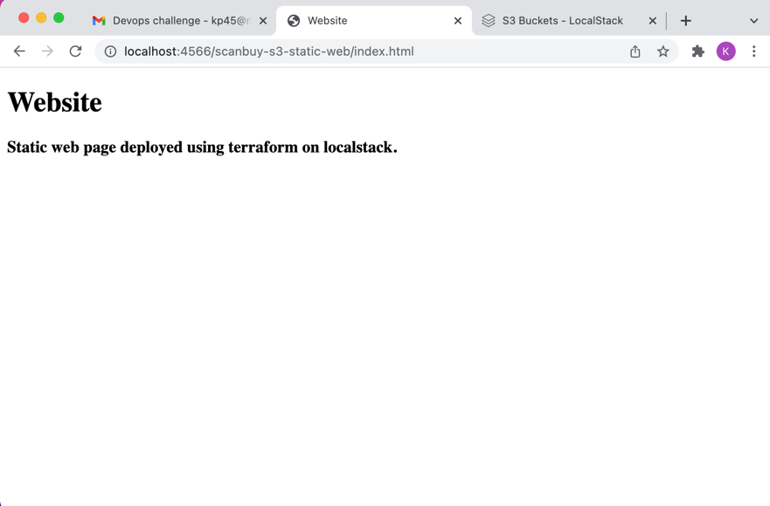

1. Serverless

To be honest, I am having trouble in this exercise, as I never used serverless before, so I can’t able to test the functionality. Although, I did implemented Fibonacci function using python and try to implement but it didn’t work.

Git Repo : <https://github.com/codekeyur/DevOps-Exercise/tree/master/3)%20Serverless>

1. Other ways to deploy static website in AWS

Integrating S3 and CloudFront is another to host static website on AWS and we can deploy either using CloudFormation or manually.